**Fatima Shafique**

**SU92 BSAIM S24 – 036**

**TASK : 2**

* The code runs a Fizz Buzz game, where for each round, a random number between 1 and 50 is checked. It prints "Fizz" for multiples of 3, "Buzz" for multiples of 5, and "Fizz Buzz" for multiples of both 3 and 5.

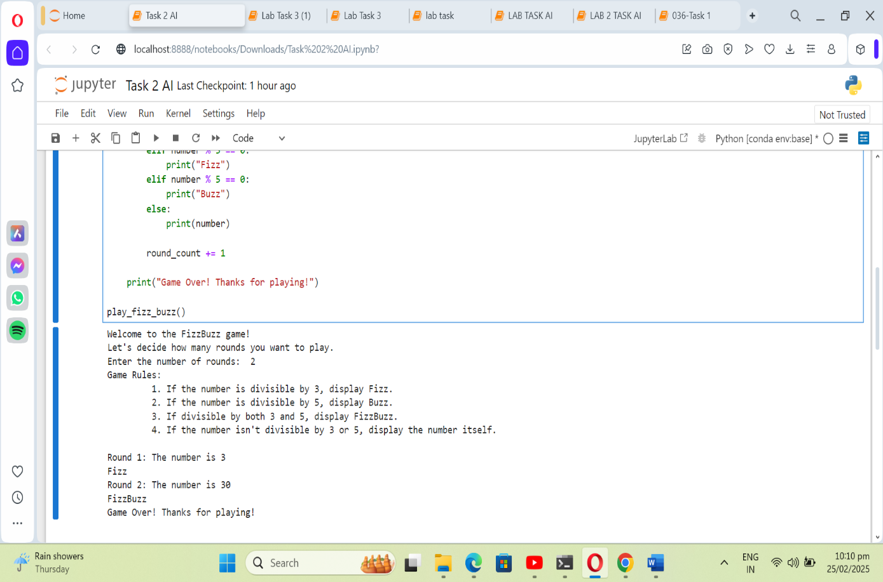**Task 2**

* The code calculates the average budget of a list of films and identifies those with a budget higher than the average. It uses functions to compute the average, filter expensive films, and display the results. Key elements include compute_average_budget and get_high_budget_films.

